New Pathways Wellbeing Circles
EXPLORING FOUNDATIONS OF WELLBEING
12th September 2018

This month’s program will explore the value and meaning of time. The basic measure that impacts every part of our life. Do we all see ‘time’ in the same way?

A SENSE OF TIME

Time is a created thing. To say, 'I don't have time,' is like saying, 'I don't want to.”
Lao Tzu

How did it get so late so soon?”
Dr Seuss

The paradox of our time in history is that we have taller buildings, but shorter tempers; wider freeways, but narrower viewpoints; we spend more, but have less; we buy more, but enjoy it less.

We have bigger houses, but smaller families; more conveniences, but less time; we have more degrees, but less sense; more knowledge, but less judgement; more experts, but more problems; more medicine, but less wellness.

We have multiplied our possessions, but reduced our values. We talk too much, love too seldom, and hate too often. We’ve learnt how to make a living, but not a life; we’ve added years to life, but not life to years.

We’ve been all the way to the moon and back, but have trouble crossing the street to meet the new neighbour. We’ve conquered outer space, but not inner space; we’ve cleaned up the air, but polluted the soul; we’ve split the atom, but not our prejudice.

We have higher incomes, but lower morals; we’ve become long on quantity, but short on quality. These are the times of tall men and short character; steep profits and shallow relationships.

These are the times of world peace, but domestic warfare; more leisure, but less fun; more kinds of food, but less nutrition. These are the days of two incomes, but more divorce; of fancier houses, but broken homes. It is a time when there is more in the show window and nothing in the stock room; a time when technology can bring this letter to you, and a time when you can choose to make a difference.
Columbine student

It's being here now that's important. There's no past and there's no future. Time is a very misleading thing. All there is ever, is the now. We can gain experience from the past, but we can't relive it; and we can hope for the future, but we don't know if there is one.”
George Harrison
O SON OF BEING! Bring thyself to account each day, ere thou art summoned to a reckoning; for death, unheralded, shall come upon thee and thou shalt be called to give account for thy deeds.
Baha’i Writings

Begin at once to live, and count each separate day as a separate life.
SENECA
For everything there is a season, and a time for every matter under heaven:
a time to be born, and a time to die;
a time to plant, and a time to pluck up what is planted;
a time to kill, and a time to heal;
a time to break down, and a time to build up;
a time to weep, and a time to laugh;
a time to mourn, and a time to dance;
a time to throw away stones, and a time to gather stones together;
a time to embrace, and a time to refrain from embracing;
a time to seek, and a time to lose;
a time to keep, and a time to throw away;
a time to tear, and a time to sew;
a time to keep silence, and a time to speak;
a time to love, and a time to hate;
a time for war, and a time for peace.”

Ecclesiastes 3

There is nothing quite as difficult for man as waiting for time — for one’s five minutes. It always seems that the time has come, right now, this minute, and, if you do not take it, then you will regret it for the rest of your life.
Time is a highly valued commodity, time is money, it is guarded like a jewel, man looks up to time as, in time, time devours all things. And, if this is true, then time is master of the entire world. For those who do not have time, and for those for whom time is not on their side; either way, rather a bleak future. The poor man; his time is up. No wonder then that we say there is a time and place for all things.
Time is indefatigable. Despite its age, it always strides at the same pace; like human fate, it reminds us of our rancour, it gnaws at insignificant human filth, and, at times, strange, dark times come to us all. This usually occurs when too much evil has been accumulated in the world in which we live, so that plain human goodness endures for less than a lifetime, sorrow is greater than any joy, and man becomes possessed by some kind of madness. It is then that time waits for no man. It is the judge and the jury. And those who remain as witnesses to bygone times continue to warn all those yet to come for a long time to come. In the beginning, their voices are strong, and then later they fall quiet, until finally it does not seem to matter anymore. But it does matter, as man constantly makes the same mistake; he destroys that which has been created in time and through time.
Time has its own aroma; it is a part of us all, our beautiful moments and those other moments, difficult moments, which we then spend a lifetime trying to forget, but to no avail.
No one knows what time has in store for him. It deals out to each man what he deserves. And we can rage as much as we want, we can think up thousands of reasons that should have influenced our fate otherwise, we can scream and curse in pain at the world, but, in the final analysis, time will inexorably rule in its own favour.
Sinisa Glavasevic

A man who dares to waste one hour of time has not discovered the value of life.
Charles Darwin

Yesterday is gone. Tomorrow has not yet come. We have only today. Let us begin.
Mother Teresa
Spring passes and one remembers one's innocence. Summer passes and one remembers one's exuberance. Autumn passes and one remembers one's reverence. Winter passes and one remembers one's perseverance.”
Yoko Ono

There comes a time when the world gets quiet and the only thing left is your own heart. So, you'd better learn the sound of it. Otherwise you'll never understand what it's saying.”
Sarah Dessen

A Story
Once an old man and a young man were sitting on the shore of a wild and stormy river.
“Sir,” the student asked, “Why does the time flow straight, but always ripples, either slowing down to a complete stop, or racing like a cow with a thistle under her tail?”

The old man looked at the seething water and answered:
“You see there are a few large stones in the river and a lot of small pebbles. Imagine that the river is your life. If you will only rejoice over big occasions – like your wedding that will happen next month, or like a new baby that you will have after one year, or new business that you will start after five years – then you will cross your life in a few jumps, like jumping from one stone to another. Otherwise, if you will move in small paces over the pebbles, taking joy in small things: a sunny day, the beauty of autumn forest, a good conversation, then later looking back at your life you won’t see ten big stones, but lots of your own traces, and each of them you will be able to remember with a happy smile. And you will see that the road that you have crossed is much longer.”

“But Sir, when I love or when I do the work that I like or when I have a talk with friends – the time flies fast. But the time drags so long when I’m hurt, when I’m afraid or when I feel lonely.”

“You see,” the old man answered wistfully, “This is what it should be. When we are unhappy, we don’t live but we only exist, so the time lies still in our wallets. And only for our happiness we pay the ringing coin of time, that we still have left.”
Anon
It is spring again. The earth is like a child that knows poems by heart.
Rainer Maria Rilke

In the absolute sense... there is nothing that remains the same even for two consecutive moments; for the Five Khandhas, or Groups of Existence, are in a state of perpetual change, of continual dissolution and renewal. They die every moment, and every moment new ones are born. Hence it follows that there is no such thing as a real existence, or "being", but only as it were an endless process, a continuous change, a "becoming," consisting in a "producing," and in a "being produced"; in a "process of action," and in a "process of reaction, "or "rebirth."

This process of perpetual "producing" and "being produced" may best be compared with an ocean wave. In the case of a wave, there is not the slightest quantity of water travelling over the surface of the sea. But the wave structure, that hastens over the surface of the water, creating the appearance of one and the same mass of water, is, in reality, nothing but the continuous rising and falling of continuous, but quite different, masses of water, produced by the transmission of force generated by the wind. Even so, the Buddha did not teach that Ego-entities hasten through the ocean of rebirth, but merely life-waves, which, according to their nature and activities (good, or evil), manifest themselves here as men, there as animals, and elsewhere as invisible beings.
Buddha

The greatest gift you can give someone is your time. Because when you give your time, you are giving a portion of your life that you will never get back.
Unknown

When a bird is alive, it eats ants. When a bird is dead, ants eat the bird. So, time can turn at any time, don't devalue anyone in life. You may be powerful but time is more powerful than you. "One tree makes one thousand of match sticks, but one match stick can burn one thousand trees
Unknown

When our heart has been broken. If by a person, or an event in our life. Everyone in the world can tell us it will be alright, and that the pain will go away. They can tell us every comforting thing in the world. But at that time, at that very time, all we hear is our broken heart. There is only one true thing that can mend this. Only one thing. That one thing is time. It takes time to mend our heart and soul. And though we can not see that, it’s only after time, that we can look back at that moment in our lives and say, “It just took me time”.
Unknown

Be generous in prosperity, and thankful in adversity. Be worthy of the trust of thy neighbour, and look upon him with a bright and friendly face. Be a treasure to the poor, an admonisher to the rich, an answerer of the cry of the needy, a preserver of the sanctity of thy pledge. Be fair in thy judgment, and guarded in thy speech. Be unjust to no man, and show all meekness to all men. Be as a lamp unto them that walk in darkness, a joy to the sorrowful, a sea for the thirsty, a haven for the distressed, an upholder and defender of the victim of oppression.
Baha’i Writings
Thank you for joining us this evening.
We hope you enjoyed the reflections and discussions.
Please join us for light refreshments.

Thank you to TATIN for assisting with refreshments tonight.

They offer amazing bakery items baked daily - including bread, donuts, pastries and tea and coffee.

TATIN - Find them at 143 Bulleen Rd, Balwyn North

Open – Wednesday to Sunday

Thank you for joining our Wellbeing Circle. We have initiated these monthly sessions so we can pause and reflect on the important foundations of life - the things that make the difference in our own wellbeing, in how we build connections and a sense of purpose.

Our Wellbeing Circles are free for clients, the general-public, family and friends. We hope they allow us to give back to the community and compliment the New Pathways Life Coaching 1 to 1 sessions.

Please feel free to invite family and friends to a future session. Please book online.

Next Session - Wednesday October 10th 7.30pm-9.00pm

Theme – The Inner Landscape

Venue tbc
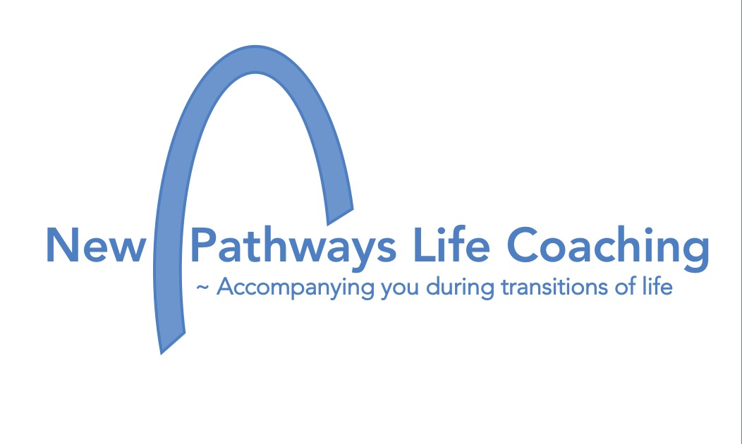 | For more information  Annette Subhani  Newpathwayslifecoaching.com.au  Newpathwayslc@gmail.com  Facebook.com/newpathwayslifecoaching  0418 320 138

